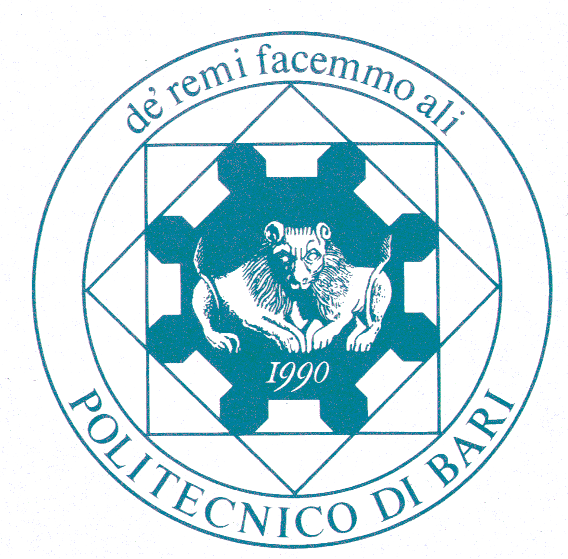
POLITECNICO DI BARI

D. R. n. 184

Art. 1 As of the date of this decree and up to 03.04.2020 or, in any case, until the persistence of this medical emergency, all exams shall be carried out exclusively through telematic instruments, through platforms such as Skype or Microsoft Teams.
Art. 2 It is mandatory to identify candidates before the exam. Before the exam can take place, candidates must display their formal and valid I.D. through platforms such as Skype or Microsoft Teams.

Art. 3 The President of the Committee will take care of setting up online exams. The necessary link to access the exams will be communicated, via email, to all students who have enrolled for the exam on platform esse3 as well as to those who will request it.

Art. 4 In accordance with Article 17 comma 3 of the Didactic Regulations of the University, the exams shall be carried out by means of interviews through telematic instruments. The Commission is entrusted regarding the choice of adequate telematic instruments concerning the testing of practical parts of the courses.

Art. 5 The exams calendar will take into account any possible postponed activities and it will be published on the esse3 platform.

Bari, 10 March 2020

